Day 6 : Reports & Metrics (Veeva-Critical) (2 Hours)
Learnt
- TestRail reporting capabilities
TestRail can generate:
- Execution status reports
- Defect-related reports
- Historical trend reports
- Audit-friendly exports
Reports can be:
- Project-level
- Milestone-level
- Test Plan / Test Run-level
- Key reports:
  - Test Summary - How much testing is completed and what is the overall quality?
Shows:
- Total test cases
- Passed / Failed / Blocked
- Completion %
  - Results by Status - Exactly how many tests are in each execution state?
Shows:
- Passed
- Failed
- Blocked
- Untested
- Retest
  - Defect Summary - What quality risks remain?
Shows:
- Number of failed tests
- Linked defects (if integration exists)
- Failure trends
⚠️ Even without Jira integration, this report is still used.
- Audit & compliance importance
Requirement → Test Case → Execution → Defect → Release Sign-off
- Versioned test cases
- Execution history per release
- Comments and attachments
- User-based execution logs
- Limited electronic signature support (tool + process)

Practical
- Generated execution reports
Steps:
- Go to Reports
- Select Defects Summary
- Scope:
  - Test Run or Test Plan
- Generate
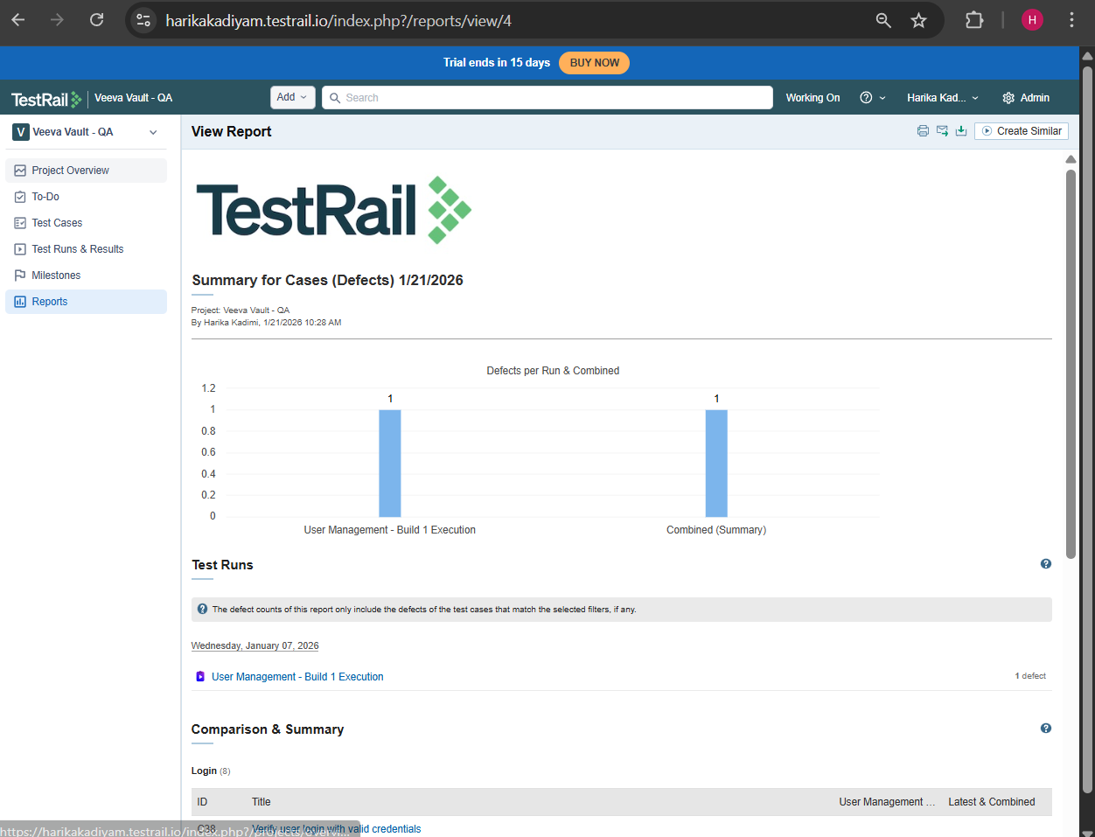
- Exported reports (PDF / HTML)

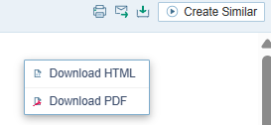
- Reviewed historical data
Steps:
- Generate same report
- Change:
  - Milestone
  - Date range
- Compare pass % / fail %
Why auditors care
- Shows process consistency
- Shows quality improvement
- Detects repeated failures

